Q1. “A conservative is a man with two perfectly good legs who, however, has never learned how to walk forward”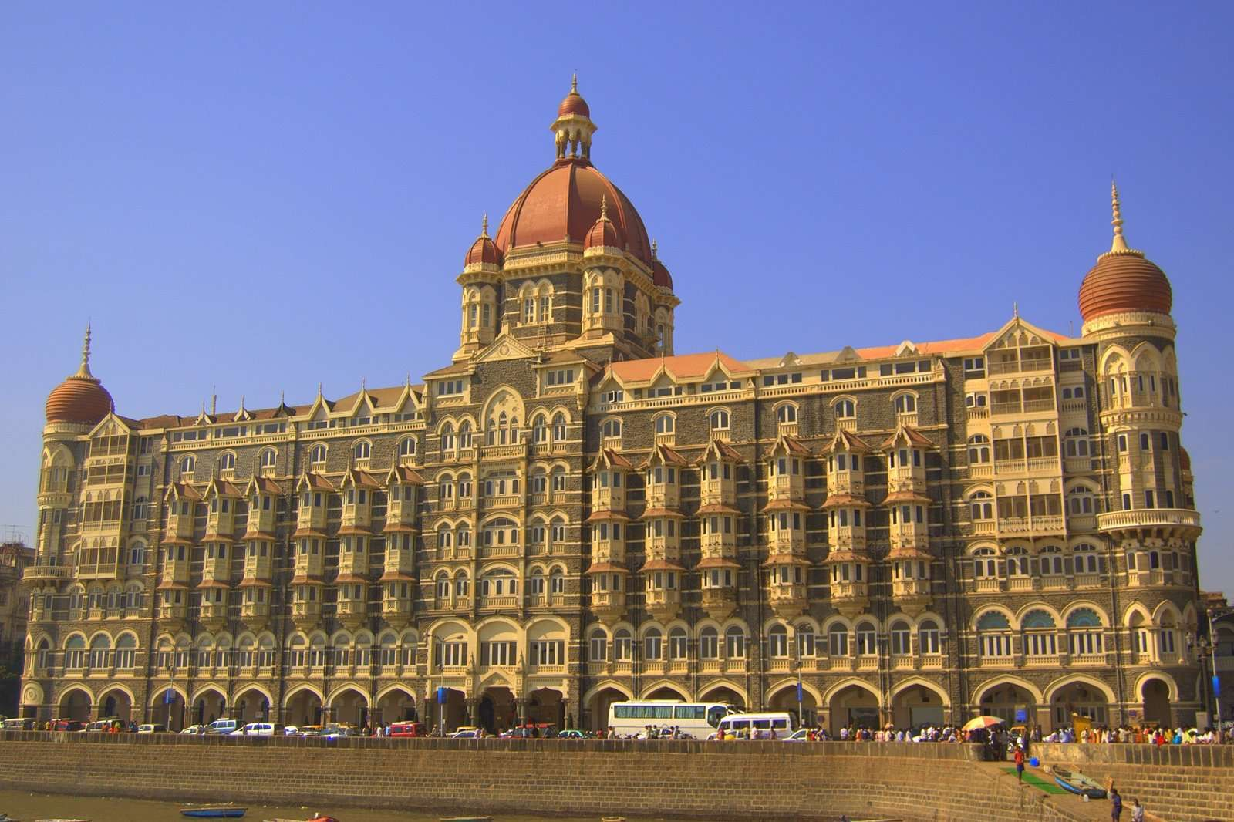

Hotel is your key.

Ans — Waldorf Astoria Hotel

Q2.“Let's go for a drive”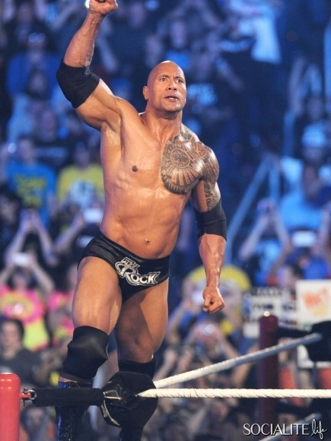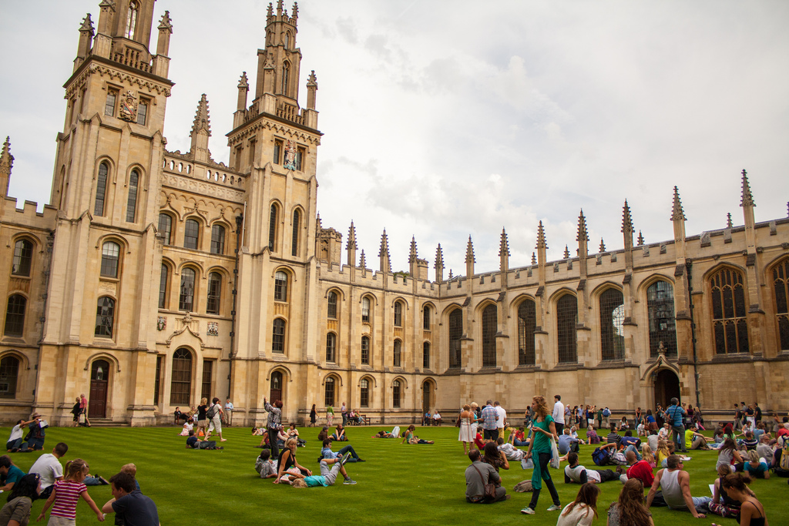

Ans — Zyxt

Q3. I rule the seas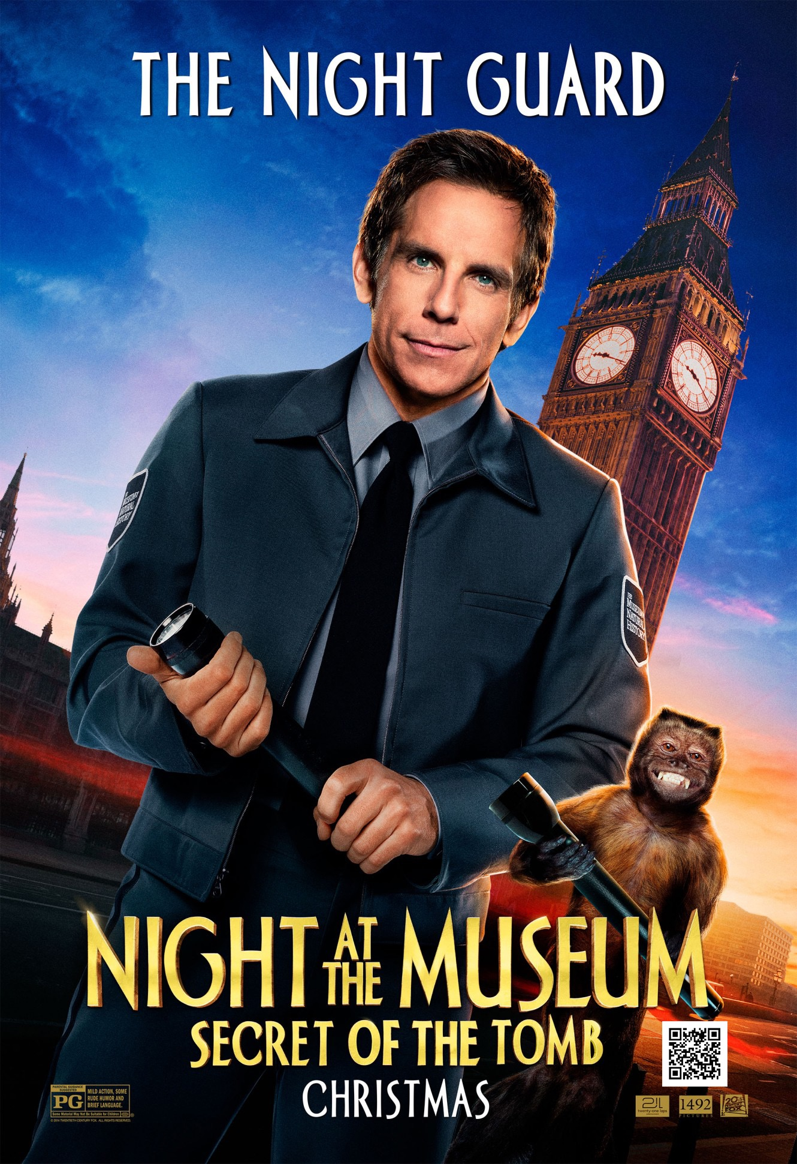



Ans — HMS Resolute

Q4. I am a cloud.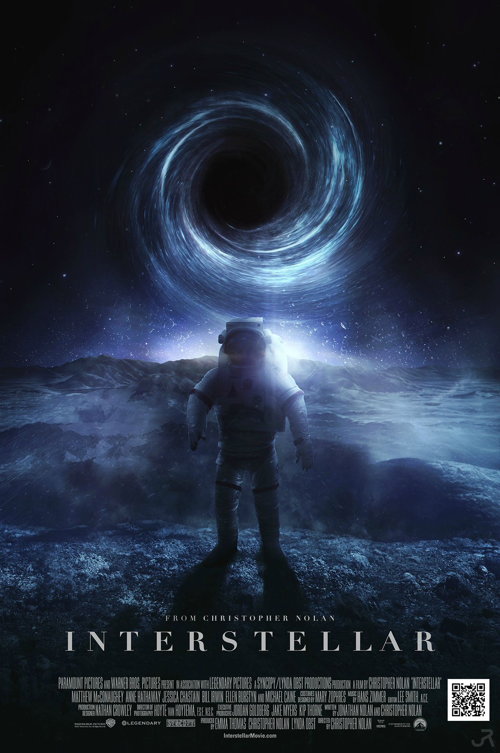

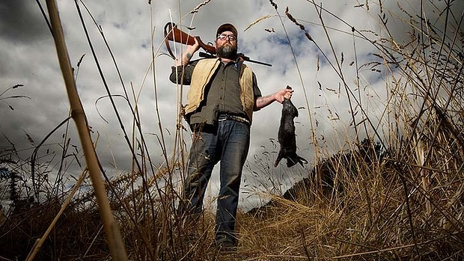

Ans — Horsehead Nebula

Q5. I am a Duck and I can give you anything on the net, but I won’t remember your wishes.

Q6. It is a very useful ratio in physics.



Ans — Poisson’s ratio